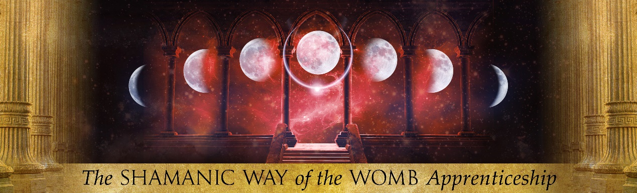
Application for the Shamanic Way of the Womb Apprenticeship October 2024/25
Please answer all questions with courageous honesty; everything will be treated in the strictest confidence. You can answer briefly if you don’t ‘know’ at this moment. This is not a test, just a sharing of yourself. All of your experiences – ‘light and dark’ – are welcomed - often our deepest wounds hold the greatest gifts. You do not ‘need’ any formal womb healing experience, as the Mystery Teachings of the Old Ways will initiate you!
Womb Witch/Priestess/Shamanka Application Form
Today’s Date:
Name:
Birth name (if different):
Date of birth:
Email address:
Home address:
Telephone number:
Facebook Name:
In Relationship?
Do you have children?
Your current work or vocation?
Do you experience any physical/mental/emotional illness?
Are you currently taking any medication?
Have you ever been treated for a mental disorder or illness?

Womb Priestess/Witch/Shamanka
What does being a Womb Priestess mean to you personally?
What gifts do you feel you have embodied?
Have you had any womb healing experiences?
What do you wish to gain from this Apprenticeship?
What do you wish to offer to others with this Apprenticeship?
What aspects of the Apprenticeship makes your heart sing?
What aspect of the Apprenticeship feels challenging?
Describe why you feel CALLED and compelled to this work?
Do you feel ready for RADICAL transformation if called?

Previous Training and Qualifications
Describe briefly any previous training, qualifications or experience you have that you think may be relevant to the Shamanic Way of the Womb Apprenticeship ?

Which of the following ways of learning do you feel most comfortable with to learn and communicate?

Physical/experiential (e.g body work, physical touch, experience)
Mental/inspiration (e.g books, words, ideas, communication)
Feeling/intuitive (e.g. emotions, transmission, psychic inner journeys)
Womb Priestess Lineages
Describe briefly any Goddess lineages you have worked with, experienced or been inspired by previously, if any?

Which Goddess do you feel most drawn to at this moment, if any?

Have you ever had a powerful experience at a Sacred Site?

Do you tend a garden or commune with nature?

Do you have an animal totem or a favourite animal?

Do you consciously work with your dreams?

What do you wish to add to this application? (sit quietly for a moment, place your hands on your heart and your womb ask…)
Please describe the work you currently do:
Have you received any womb healing?
Is there anything else relevant to the application you would like to include?
Angie will be in touch about an informal interview with 48 hours of receiving your application. DO NOT send any deposits or payments before your place is confirmed. Thank you.

THANK YOU FOR YOUR APPLICATION AND HONEST SHARING

