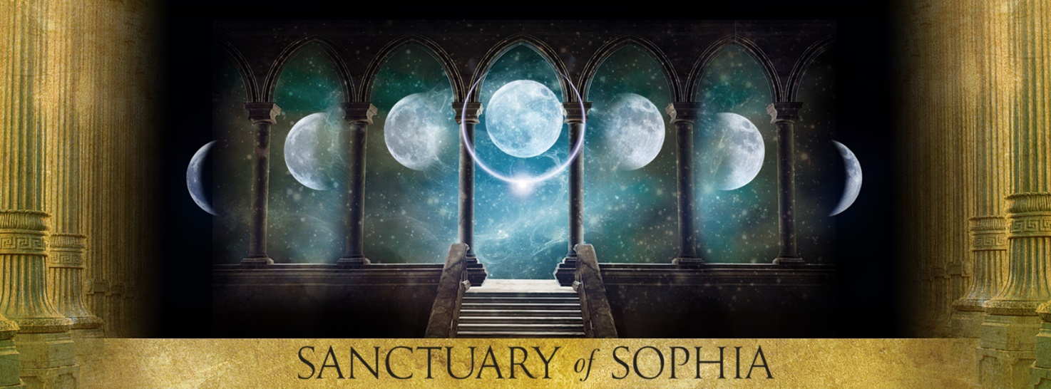
Shamanic Womb Healing with
Tuning Forks
Course Application Form
Please return this application directly to Angie via info@sanctuaryofsophia.co.uk
Your
Photo
Here

Name:
Email:
FB Name:
Skype Name:
Phone Number:
Address:

Anatomy & Physiology Qualification:

Massage Qualification:

Tuning fork qualifications/experience:

Healing qualifications/experience:

Relevant Experience:

Please describe the work you currently do:

Have you received any womb healing?

Is there anything else relevant to the application you would like to include?

Angie will be in touch about an informal interview with 24 hours of receiving your application. DO NOT send any deposits or payments before your place is confirmed. Thank you.

Payment Terms

The full price for the Shamanic Womb Healing with Tuning Forks is £593. A non-refundable deposit of £100 upon application secures your place. Upon acceptance into the training, the remainder of the balance becomes payable in full or by instalments.
Payment Schedule: I agree to pay the fee for the Training as follows:
Please tick box:-
OPTION 1 - £593 paying the full amount in one instalment.
OPTION 2 - £593, payable in three instalments of £164.33, which must be paid in full before the start of the course.

TERMS AND CONDITIONS*

By signing this page, you are signing a legal agreement. Please Read Carefully.
1.To complete the course students are expected to attend every training day and to complete all coursework on time. Failure to do so may result in a student being asked to leave the course.
2. A course place is only secured on the acceptance of a completed application form and receipt of a non- refundable deposit. If, for any reason, a student cancels there is no refund of the deposit. We advise students to take out independent cancellation insurance to protect against loss in the event of illness, injury, jury service and other difficulties preventing the completion of a course. You would receive your deposit back in full in the event of The Sanctuary of Sophia cancelling the course for any reason.
3. Course fees are to be paid in full prior to the course start date or by 3 instalments
4. Students are responsible for their own well-being at all times and must inform the teacher of any matters affecting their health for the duration of the course.
5. Because the nature of the course is transformative, students who are in need may be required to undertake additional psychotherapeutic counselling to help them address personal issues, in order to continue with the course.
6. The course tutor reserves the right to ask a student to leave the course.
7. All students shall respect the other course participants irrespective of race, colour, creed or gender and will endeavour to respect any values that may be different from their own.
8. Confidentiality provides privacy and safety within the group. Whilst there is no automatic presumption that all information given is confidential, students must work within the guideline that all personal information about group members is confidential.
9. Should difficulties arise with another member of the group, students must call upon the group, the Tutor, or a mediator for mediation and resolution.
10. No refund is given once the Shamanic Womb Healing training has started. Commencing the first days training contractually commits you to full payment of the course fees, whether students are asked to leave or decide to discontinue, and independent of completion or not of the training offered.
11. Shamanic Womb Healing training is a CPD journey of empowerment which is transformative and experiential. Though it may be experienced as therapeutic, it is not therapy, it is a soul-quest and a Continuing Professional Development training.

Disclaimer The Sanctuary of Sophia and it’s tutors enforce all known safety methods that are seen to be correct in the light of current understanding of your course subject. The Sanctuary of Sophia and its tutor are not, and will not, be held liable for any assumed damage that is deemed to occur at any time. Participants must accept that all knowledge is given in good faith. Participants must understand that they are entering into training in a pioneer field and all such training is given in good faith to the highest known safety standards of known or perceived practices within this discipline and that though they may experience the teachings as therapeutic, but not diagnostic. This does not replace medical advice. If required, participants must undertake their own individual practice insurance.
Please tick box and sign
I have read the terms and conditions above. Signature........

Confirmation and Agreement

I confirm that I take full responsibility for my own health and health related decisions whilst I undertake this course. I confirm that I have read, understood and agree to abide by The Sanctuary of Sophia course booking terms, I have read the Training Information, conditions and disclaimer and that the above information I have given is true and correct. I hereby state that I, or any persons acting on my behalf, will not hold or claim against Angie Twydall, the Sanctuary of Sophia, or any of the trainings, tutors or estates for any damages assumed or otherwise for any conditions, be it emotional, mental, spiritual, physical or financial relating to my training with them.

Please tick to agree
I have read the confirmation and agreement above. Signature....................................

